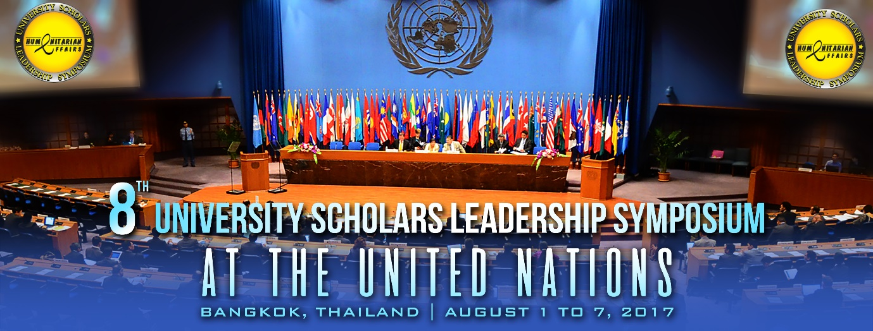

**Humanitarian Affairs UK** and the **United Nations Development Program ( UNDP )** are looking for **7 Outstanding Young Leaders** to attend the prestigious **8th** edition of the **University Scholars Leadership Symposium 2017** from August 1 to 7 at the **United Nations** in Bangkok, Thailand.

We are looking for 1,000 competent and compassionate student leaders representing their university and country in this largest youth gathering for Emerging Young Leaders.

Qualities we are searching for in this Global Leadership Development in Social Change program :

1. Young Leaders with exceptional leadership skills.
2. Young leaders with great knowledge on current world affairs.
3. Most importantly, young leaders with strong desire to build a sustainable and just world. To be the *Voice for the Voiceless.*

Please send in your **CV and your Delegate Application form** by **May 31st**. Interview might be conducted. We will stop accepting applicants once all the places are taken up as there is LIMITED SEATING at the United Nations.

Successful applicants will receive the Letter of Acceptance ( LoA ) within 3 to 5 working days.

For more information visit our website at [www.universityscholars.org.uk](http://www.universityscholars.org.uk) or simply write in to [myllane.kebir@humanitarianaffairs.org](mailto:myllane.kebir@humanitarianaffairs.org) for a copy of the application form.

You will not want to miss out on this opportunity to connect with some of the brightest young minds around the world.

Click on the video link below for a glimpse of other young leaders who have completed this week-long program successfully!

[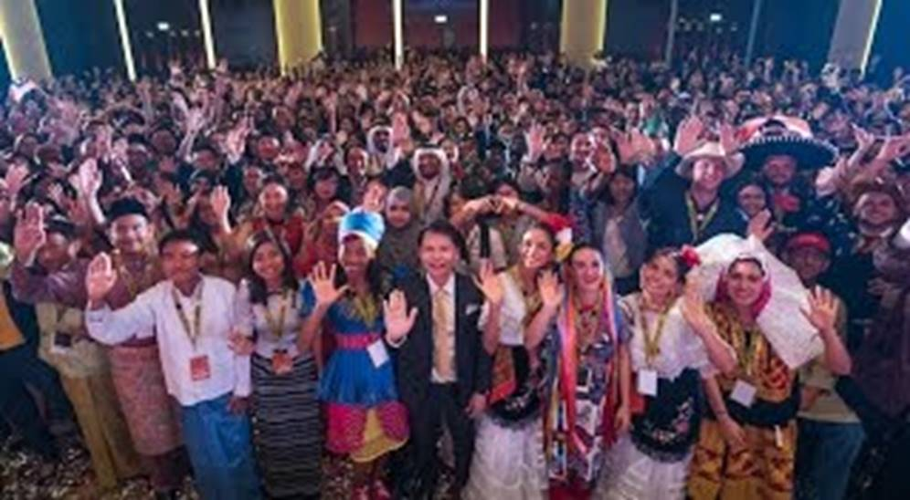](http://v.youku.com/v_show/id_XMTY3NTQ3MjU2MA==.html?from=s1.8-1-1.2)