2016 Global Ambassador Scholarship

Welcoming international students to Sam Houston State University
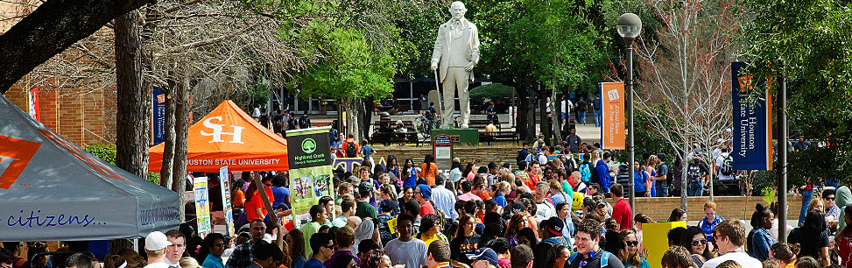
The Global Ambassador Scholarship at Sam Houston State University’s English Language Institute is designed to recruit international students who can act as ambassadors for their home country during their time at SHSU, and as ambassadors for SHSU when they return to their home country.
Details:
- The scholarship will cover application fee and half of tuition for ONE 8-week session of study, valued at $1300.
- Students will be responsible for all other fees (flight, immigration fees, university fees, housing, insurance, books, daily expenses, etc.)
To apply, students must send the following documents to eli@shsu.edu:
- Global Ambassador Scholarship application WITH essay (on a separate paper)
- ELI application. Please note: The application fee is waived for scholarship applicants
- Transcripts: Scanned copies of transcripts from your most recently attended school, in English
- Bank statement: Proof of financial means (ability to support yourself) in the amount of at least $18,500 USD (required for F1 student visa)
- Copy of valid passport: The passport expiration date must be at least one year after your expected program state date.
- TOEFL or IELTS test results (if available). All students will do a Skype placement interview with ELI staff after being selected as a scholarship finalist.

Deadlines:
Fall I (August 22 – October 21) DEADLINE: July 1st, 2016
Fall II (October 24 – December 21) DEADLINE: August 12th, 2016

Contact Dana Van De Walker, International Student Recruiter, at d.vandewalker@shsu.edu for more information.

