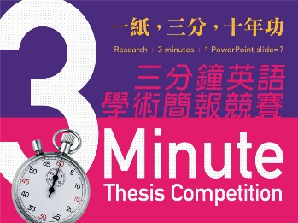
Contact: ntuawec@ntu.edu.tw

2016 NTU Three-Minute Thesis Competition

The 2016 NTU Three-Minute Thesis Competition will be held at National Taiwan University from April to May. The competition is open to currently-enrolled Northern Taiwan Section II partner university graduate students.

The Three-Minute Thesis (3MT), originating at the University of Queensland in Australia, is an international research communication competition that challenges higher-degree students to present to an intelligent, but non-specialist, audience the ideas they are researching, the new knowledge they are hoping to find, and the contribution their research is going to make.

The 3MT is held at some of the top-ranking universities in the world. As the first authorized institution in Taiwan to present this English-language research communication event, National Taiwan University now joins them to present its own 3MT event and invites you to participate.

【Key Dates】
3MT Seminar: 2016/4/08 (Fri.) 13:30-16:30 National Taiwan University
Video Submission: 2016/4/8 (Fri.) - 5/2 (Mon.) 12:00 Online
Final: 2016/5/31 (Tue.) 17:30-20:00 National Taiwan University

【Prizes】
One Winner: iPad Air2
One First Runner-Up: Asus Tablet
One Second Runner-Up: Pocket Projector
One Audience Choice Award: Pocket Projector

【Organizer】
National Taiwan University Academic Writing Education Center

【Co-Organizer】
Second Northern Taiwan Teaching Resource Center
National Taiwan University Office of Academic Affairs
National Taiwan University College of Liberal Arts

For more information, please visit the event website http://www.awec.ntu.edu.tw

