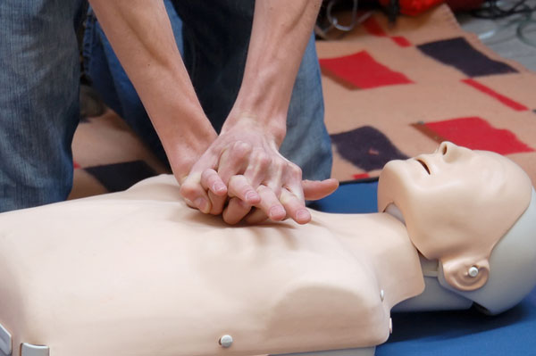 CPR+AED
Explanation: In view of increasing emergencies around the campus, the health center plans to set up an emergency medical system for campus security by enhancing foreign students’ self-help capabilities in the hope that they can handle some incidents in time to reduce harm to the least!
Date: October 8, 2014(Wednesday) Time: 18:00-21:00
Instructor: Advanced BLS instructor of ROC Red Cross Society, Hualien branch
Place: Humanities and social building II,F2, B211 classroom
Objects: Foreign students at NDHU
Sign-up: Please sign up at the office of international affairs(OIA)
Number: 30 persons

Contents of workshop
Time | lessons
18:00 – 19:00 | An Introduction to First Aid
19:00 – 20:00 | CPR+AED
20:00 – 21:00 | Group practice

