10 S10 SMART RULES TO BIKE SAFETY

 | - Protect Your Head  Wear a helmet. | 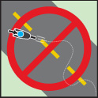 | - Act like a Car  Drivers are used to the patterns of other drivers. Don’t weave in and out of traffic. The more predictably you ride, the safer you are. Check for traffic. Be aware of traffic around you.
 | - Stay Visible  If drivers can see you, they are less likely to hit you. Use lights when biking at night or in low-light conditions. | 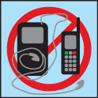 | - Don’t Get Distracted  Don’t listen to music or talk on the phone while riding.
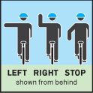 | - Look, Signal & Look Again  Use hand signals to let drivers and other bicyclists know where you’re going. Look and make eye contact. Don’t assume drivers will stop. | 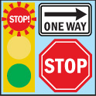 | - Obey all Traffic Laws & Lights
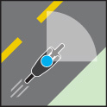 | - Stay Alert  Keep a lookout for obstacles in your path. | 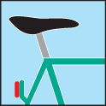 | - Assure Bicycle Readiness  Is your bicycle properly adjusted? Is your saddle in a comfortable position?
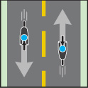 | - Go with the Flow  Bike in the direction of traffic. | 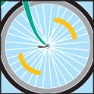 | - Do a Quick Bicycle Test  Check your brakes and your wheels. Make sure that “quick release” wheels are properly secured.

