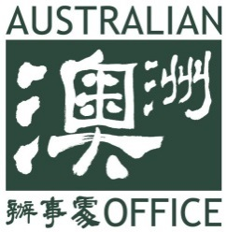
2018 Australia-Taiwan Student Mobility Forum
Venue: Australian Office
Date: Monday 19 March 2018
Last updated: 26 February 2018
09:45 – 10:30 | Session One: New Colombo Plan  Welcome and Opening  - Opening: Mr Gary Cowan, Representative, Australian Office  - Short talk: NCP Scholar  Speakers:  - TW Speaker  - TW Speaker  Q & A
10:30 – 10:45 | Tea / Coffee break
10:45 – 11:30 | Session Two: Student Mobility and New Southbound Policy  Speakers:  - Ms Eliza Chui, Deputy Representative, Australian Office  - TW Speaker, Department of International and Cross-strait Education, Ministry of Education (tbc)  - TW Speaker, Center for Teacher Education, National Taiwan University (tbc)  Q & A
11:30 – 11:45 | Tea / Coffee break
11:45 – 12:30 | Session Three: Institutional Partnerships  Speakers:  - Professor Mitchell M. Tseng, Dean and Chair Professor, International School of Technology and Management, Feng Chia University  - AU Speaker  Q & A
12:30 – 13:30 | Networking Lunch

