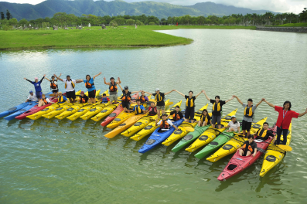

Enrolls at most 20 persons per session

Camp Time：

9th session 10/31(六) 8:30~12:30   
10th session 10/31(六) 14:00~18:00(full)  
11th  session 11/1(日) 8:30~12:30  
12th session 11/1(日) 14:00~18:00

上午 9:00 - 下午 6:00 (週末)

Held by Physical Education Center

Please e-mail sign-up form to:

[ndhuwater@yahoo.com.tw](mailto:ndhuwater@yahoo.com.tw)

Enrolment taken in time sequence of signing-up

till class is full.

Accepted enrolment notified by return e-mail.

Further details please refer to PE Center’s webpage: [http://phyedu.ndhu.edu.tw/news.htm](http://phyedu.ndhu.edu.tw/news.htm" \t "new_win)

**Kayaking Experience**

Sign-up fee/ per session

NT$160!

*Pay up on the spot*

Sale prices good through 11/17/03

Store Hours:

10:00 A.M. – 5:00 P.M. (M thru F)

9:00 A.M. – 6:00 P.M. (Sat. & Sun.)

**Daniel Escapa**  
Fine Art

98765 Main Street

Savannah, GA 98031

Located in Harrington across from Memorial Park