**Humanitarian Affairs Asia** is looking for **5** Outstanding Student Leaders from **National DongHua University** to attend the **6th University Scholars Leadership Symposium** held in Hong Kong from 1 – 7 August, 2015.

1000 scholars from top universities around the world will attend the Hong Kong Symposium. This year’s symposium is supported by the **Hong Kong Government**, endorsed by the **United Nations** and promoted on their official [Relief Web](http://reliefweb.int/training/627036/6th-university-scholars-leadership-symposium-2015).

We are searching for Student Leaders with the following qualities:

* Students who have demonstrated strong leadership potential
* Students who have a diverse and knowledgeable worldview
* Students who exhibit strong cross-cultural sensitivity and adaptability

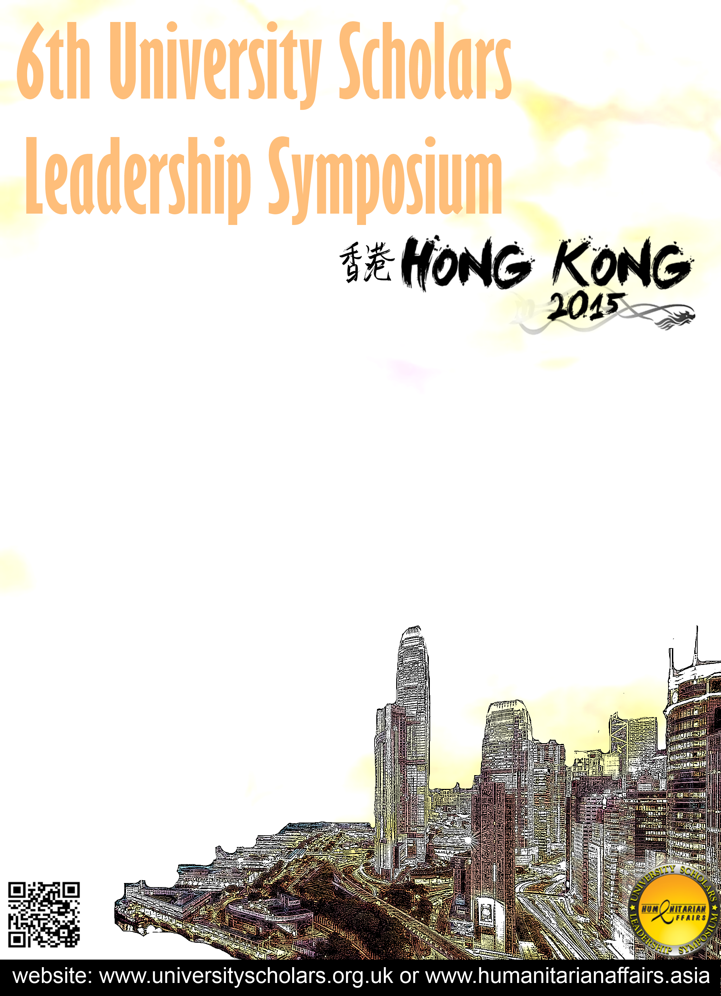

Please contact our Global Event Associate,

Anna Nalyvayko:

**E-mail:** anna.nalyvayko@humanitarianaffairs.org  
**Skype:** anna.nalyvayko.1

for more information about the Symposium, or to request a special Delegate Application Form.

The Deadline for the 1st round of applications is **31 March, 2015.**

If you’re passionate, excited about the world we live in, and believe you have something to contribute, then we want to see you in **Hong Kong!**